Project Design Phase-II
Technology Stack (Architecture & Stack)

Date | 22 February 2026
Team ID | LTVIP2026TMIDS42582
Project Name | Home-Rentals
Maximum Marks | 4 Marks

Technical Architecture:
The Deliverable shall include the architectural diagram as below and the information as per the table1 & table 2
Example: Home-Rentals Application
Reference: https://developer.ibm.com/patterns/ai-powered-backend-system-for-order-processing-during-pandemics/
Guidelines:
- Include All Processes (Application Logic / Technology Blocks):
  - Clearly represent each major process or technology block (e.g., user authentication, property search, booking, payment, notifications).
  - Use distinct shapes or icons for each process to enhance clarity.
- Provide Infrastructural Demarcation (Local / Cloud):
  - Visually separate components running locally (e.g., client/mobile app, admin dashboard) from those hosted in the cloud (e.g., backend server, database, cloud services).
  - Use shaded areas or labeled sections to indicate "Local" and "Cloud" boundaries.
- Indicate External Interfaces (Third-Party APIs, Services):
  - Show connections to external APIs (e.g., payment gateways, email/SMS services, social login providers).
  - Use labeled arrows or connectors to highlight integration points.
- Indicate Data Storage Components / Services:
  - Clearly mark all data storage elements (e.g., cloud database, file storage, cache).
  - Specify the type of storage (SQL, NoSQL, object storage) and its location (local/cloud).
- Indicate Interface to Machine Learning Models (If Applicable):
  - If your application uses machine learning (e.g., recommendation engine, fraud detection), show the interface to these models.
  - Use a distinct icon or block labeled "ML Model" and indicate data flow to/from the model.
- General Best Practices:
  - Use arrows to indicate data and process flow.
  - Label all components, boundaries, and interfaces clearly.
  - Ensure the diagram is easy to read and visually organized, with a legend if necessary.

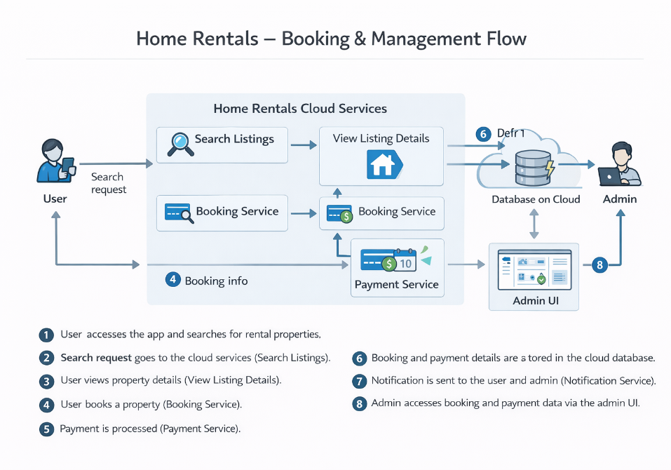

Table-1 : Components & Technologies:
S.No | Component | Description | Technology
 | User Interface | How user interacts with application (Web UI, Mobile App) | HTML, CSS, JavaScript, React.js
 | Application Logic-1 | Logic for user authentication and registration | Node.js, Express.js
 | Application Logic-2 | Logic for property search and booking | Node.js, Express.js
 | Application Logic-3 | Logic for payment processing | Stripe API, Node.js
 | Database | Data storage for users, listings, bookings | MongoDB (NoSQL)
 | Cloud Database | Database Service on Cloud | MongoDB Atlas
 | File Storage | Storage for images and documents | Local Filesystem, Cloud Storage (AWS S3)
 | External API-1 | Payment gateway integration | Stripe API
 | External API-2 | Email/SMS notification service | SendGrid API, Twilio API
 | Machine Learning Model | Recommendation engine for listings (if applicable) | TensorFlow, Scikit-learn
 | Infrastructure (Server / Cloud) | Application deployment on local/cloud systems | Local Server, Vercel (Client), AWS EC2 (Server), Docker, Kubernetes

Table-2: Application Characteristics:
S.No | Characteristics | Description | Technology
 | Open-Source Frameworks | List the open-source frameworks used | React.js, Node.js, Express.js, MongoDB
 | Security Implementations | Security/access controls, encryption, firewalls, etc. | JWT, bcrypt, HTTPS, OWASP, IAM Controls
 | Scalable Architecture | Justify scalability (multi-tier, microservices, etc.) | REST API, Docker, Kubernetes
 | Availability | Load balancers, distributed servers, cloud deployment | Nginx, AWS ELB, Vercel, MongoDB Atlas
 | Performance | Caching, CDN, request handling, optimization | Redis, Cloudflare CDN, MongoDB Indexes

References:
https://c4model.com/
https://developer.ibm.com/patterns/online-order-processing-system-during-pandemic/
https://www.ibm.com/cloud/architecture
https://aws.amazon.com/architecture
https://medium.com/the-internal-startup/how-to-draw-useful-technical-architecture-diagrams-2d20c9fda90d

